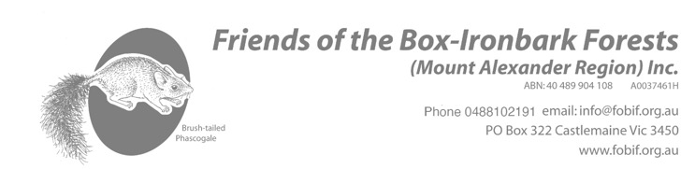
January 18, 2026
Dear Friend of the Box-Ironbark Forests,

What a start to 2026, fires, floods and destruction. We share a great sadness at the devastation on Leanganook and Harcourt Valley. This gives us pause to reflect on our precious environment and community and how each of us can find our own ways of supporting them.

We were fortunate to have Tanya Loos speak at our AGM and her book ‘Living with wildlife’ which (amongst other things) shows us how to create gardens that provide refuge during extreme weather events and tips for helping wildlife during times of crisis.

As well as our usual activities, this year we were treated to a special ‘forest healing’ session hosted by Christine and family with beautiful sound and meditation.

Our popular publications continue to inspire and are selling well. Watch this space, as there is another one coming…

The committee has spent time reviewing, developing and updating the background purposes of FOBIF. A big task! We will be sharing this as it comes together.

Our committee has seen a few changes as life circumstances change. We are grateful for the input of the members who have left and are excited to work with our new members. The current lineup is-
Christine Henderson (President) lives on the eastern edge of the Fryers Ranges, and enjoys being in the forest, admiring wildflowers in season. She loves gleaning knowledge from others: botanists, ecologists, ornithologists and other nature lovers, preferably while walking in the forest.
Lisa Hall (Secretary) lives in and loves the forest. After working in landscape architecture and outdoor education she now has time to volunteer in her favourite organisations.
Frances Cincotta (Assistant Secretary) has been running an indigenous nursery (Newstead Natives) for 26 years and supplies many of the Landcare groups, MAS Council, Connecting Country, farmers and gardeners with local provenance plants for habitat restoration.
Carolyn Crowther (Treasurer) is a passionate forest lover and resident of Spring Gully, Fryerstown, who brings her extensive experience from publishing and finance to FOBIF.
Gen Blades (Vice President & Walks Programme Coordinator) A Castlemaine local, she loves exploring the bush on foot. Gen has had a long career in teaching outdoor and environmental education in schools & universities.
Sarah Day (Media) has worked and volunteered in the environment and social justice movement for 25 years working with grassroots groups and organisations such as Goongerah Environment Centre, Victorian National Parks Association and Friends of the Earth, most recently campaigning to protect native forests. Sarah is involved in local climate, seed collecting, revegetation and wildlife projects.
Karl Just, local legend, is a botanist and zoologist dedicated to environmental advocacy and nature restoration. He has a great podcast Just Ecology .
Chrissy Charles is a well-qualified vegetation ecologist with a Degree in Plant Science & Masters of Ecosystem Management and Conservation.

Remember: FOBIF committee meetings are open to all members. They’re at the Community House building, 30 Templeton Street Castlemaine, on the second Monday of every month from February to November, at 6 pm.

Subscriptions are due now: Member subs—$10 per individual, $15 a family.
There’s a membership form with this letter.
If you’ve paid your sub since (or at) our AGM, you don’t need to heed this notice.

The popular monthly walks program is printed overleaf. It is also posted on www.fobif.org.au. Conditions can change, so please check the website for possible last-minute changes.

See you on the track!

Christine Henderson, Lisa Hall, Carolyn Crowther, Frances Cincotta, Gen Blades, Karl Just, Sarah Day & Chrissi Charles.

