TREES OF THE MOUNT ALEXANDER REGION
Tog’s Place Café 2016

1. Bundy Eucalytus nortonii
and Yellow Box Eucalyptus melliodora

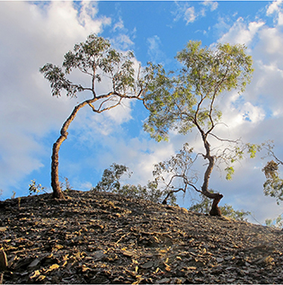

Spring Gully
Photo by Bernard Slattery
January 2016

A common and puzzling feature of goldfields landscapes is the number of trees growing out of mullock heaps. Surprisingly, there are plant nutrients in these apparently sterile piles of rocks, and sometimes the trees on them are bigger than those on surrounding flat ground. These two, however, have struggled to find a foothold on a steep slope near Spring Gully Central mine.

$95 framed $70 unframed

2. Red Box
Eucalyptus polyanthemos

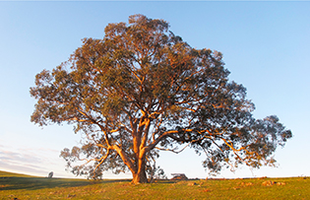

Golden Point
Photo by Bernard Slattery
August 2015

Maybe the most striking feature of the Red Box is its greyish, rounded leaves, but a burst of garish sunlight in the late afternoon of a winter’s day gave this distant tree an almost unnatural golden look.

$95 framed $70 unframed

3. Death Throes
Yellow Box
Eucalyptus melliodora

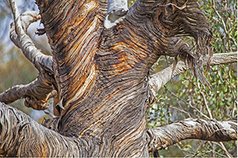

Rise and Shine Bushland Reserve
Photo by Damian Kelly
November 2015

The bark of the Yellow Box is quite variable, and it’s not unusual to see weirdly contorted shapes on the bark, especially of older trees. In this case, the twisted lines add drama to the sight of the dying tree.

$95 framed $70 unframed

4. Red Gum Regeneration
Eucalyptus camaldulensis subsp. camaldulensis

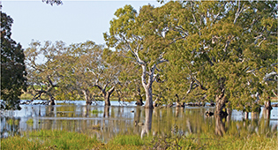

Walkers Swamp
Photo by Damian Kelly
September 2011

The flood years provided much needed regenerative life to our Red Gums, and made local swamps great places to visit. This photo was taken early in the morning, and the slanted light gave a ghostly look to these noble trees, bleaching the trunks and giving the greyish green leaves a pale, golden look.

$95 framed $70 unframed

5.Swift Parrot Lathamus discolour feeding in Ironbark

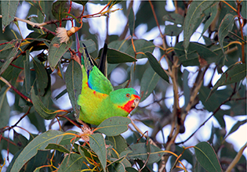

Muckleford
Photo by Deborah Worland
August 2014

‘Swifties’ breed in eastern Tasmania over summer, then in winter almost the entire population migrates north to the mainland, sometimes as far north as Brisbane. Most of them stay around Victoria, however, and here they feed on winter-flowering eucalypts and wattles. Eucalypt species utilised include the winter-flowering Grey Box, Red Ironbark, Mugga Ironbark, Yellow Gum, White Box and Red Gum (DSE 2002).

$75 framed $55 unframed

6. Buloke
Allocasuarina luehmannii

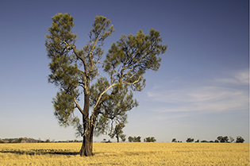

Moolort Plains
Photo by Geoff Park
January 2016

Buloke woodlands were once widespread across the Moolort Plains. Today, only small remnants
and isolated paddock trees remain.

$95 framed $70 unframed

7.Long-leaved Box
Eucalyptus goniocalyx

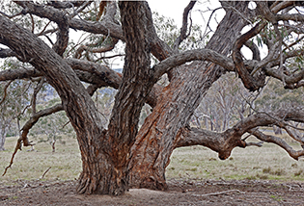

Sutton Grange
Photo by Bronwyn Silver
June 2015

Long-leaved Box is one of our most characterful trees, with a spreading habit which can look simply untidy, but more often is like a magnificent sprawl. Clearing history on our public land means that the best specimens—like this ancient tree in Sutton Grange—are on private farmland.

$95 framed $70 unframed

8. Eastern Yellow Robin
Eopsaltria australis

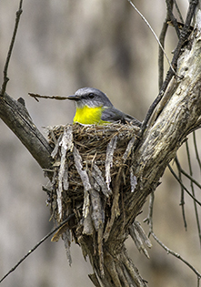
Rise and Shine Bushland Reserve
Photo by Geoff Park
August 2013

‘An Eastern Yellow Robin’s nest is a work of art – there is no other way to describe it. Thin strips of Red Stringybark and flakes of Box (Yellow and Long-leaved) are delicately woven into the rim, or stitched to form a hanging skirt around the side of the nest. The final result is a perfectly disguised cup, ready for laying. ‘ (Geoff’s Natural Newstead blog)

$75 framed $55 unframed

9. Red Gum
Eucalyptus camaldulensis subsp. camaldulensis

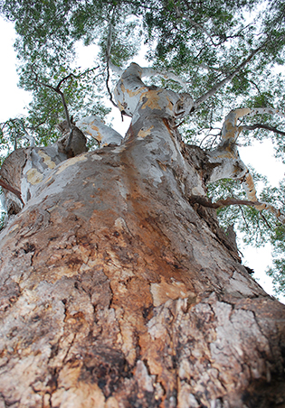

Goldsmith Crescent, Castlemaine
Photo by Jen Thomas
January 2016

Red Gum: it’s the iconic Australian tree, found in all mainland states. Stand near a big one, and you can be filled with awe. This tree predates the town of Castlemaine. The Red Gum ‘connects time, place, people, land and water, desert and forest. [Its] story is the history of our continent.’ (Peter Coloff). (Oh, don’t stand too close—Red Gums drop branches without warning.)

$75 framed $55 unframed

10. Yellow Box
Eucalyptus melliodora

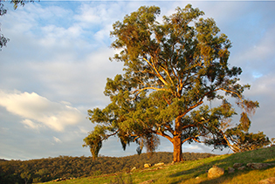
Glenluce
Photo by Ern Perkins
August 2009

One of our most famous honey trees, the Yellow Box can sometimes match the Red Gum for grandeur of habit. Some noble specimens can be observed from the Glenluce-Drummond Road, on farmland.

$95 framed $70 unframed

11. Red Gum
Eucalyptus camaldulensis subsp.camaldulensis

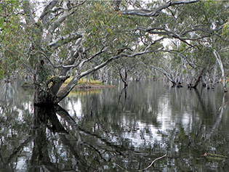

Bells Swamp
Photo by Chris Worland
November 2011

Compare the colour of the foliage on these trees with the trees in Damian Kelly’s Walkers Swamp photo to see the effect that light can have on colour. Floods can be disastrous for those in their way, but they’re a natural (and essential) part of our landscape, and the revitalisation of our swamps was an inspiring feature of the wet years.

$95 framed $70 unframed

12. Yellow Gum
Eucalyptus leucoxylon subsp. Pruinosa

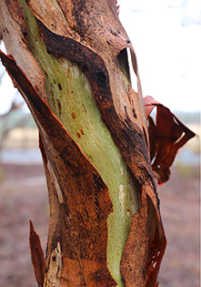

Walmer
Photo by Mitchell Parker
January 2016

The stately Yellow Gum is a feature of many parts of our region. One of its most attractive features is the extraordinary colour variations on the trunk as it sheds its bark in the summer months. This photo was taken after rain added a sheen to the green colour of the new bark.

$75 framed $55 unframed
13. Red Gum
Eucalyptus camaldulensis subsp. camaldulensis

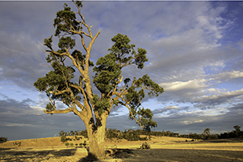

Plaistow Homestead, Joyces Creek
Photo by Geoff Park
February 2016

The land around Plaistow was selected by a
Colin MacKinnon, who selected it in 1840. This magnificent River Red Gum certainly pre-dates
this first wave of pastoral settlement and would have been a feature of the country of the Jaara people for perhaps the past 500 years.

$95 framed $70 unframed

14. Shafts of Light
Fryerstown
Photo by Marion Williams
July 2014

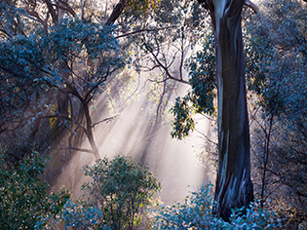

Angled morning or afternoon light is often best for showing the features of our bush, as in this photo. The defining tree on the right is a Yellow Gum.

$95 framed $70 unframed

15. Scar Tree

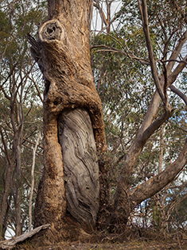

Golden Point Road
Photo by John Ellis
December 2015

The scar on this tree is an eloquent reminder of Aboriginal life in this region, and of the different layers of meaning in our landscapes. The tree is a Yellow Box Eucalyptus melliodora, a battle scarred veteran of other times.

$95 framed $70 unframed

16. Nankeen Kestrel
Falco cenchroides

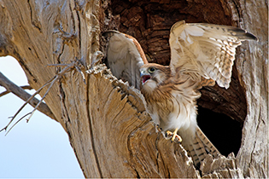

Moolort Plains
Photo by Patrick Kavanagh
January 2014

Tree hollows are vital for the survival of much of our wildlife, so even dead trees can be important features of the land. The photo shows one of three fledglings raised in this hollow on the Moolort Plains. The other two have just ventured from the nest. This one seems to be stretching in preparation for the big step out.

$95 framed $70 unframed

17. Yellow Gum landscape

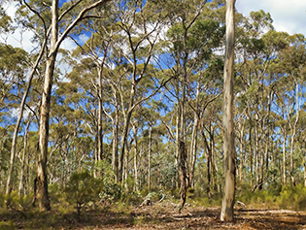

Red, White & Blue track,
Muckleford
Photo by Harley Parker
April 2014

Yellow Gums have distinctly cream (or, in summer, multi coloured) bark, are characteristically straight trunked and grow to a reasonable height, so to be in a Yellow Gum woodland is to have the impression of moving between stately columns, as in much of the Muckleford area forests.

$95 framed $70 unframed

18 Shell Lerp on Eucalyptus leaf

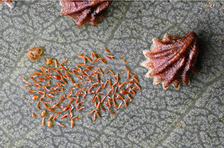

Strangways
Photo by Patrick Kavanagh
January 2015

Our trees are hosts to an amazing variety of life forms, and the macro lens can reveal sights barely visible (or effectively invisible) to the naked eye: in this case, what could seem to be an anonymous brown crust on a Grey Box Eucalyptus microcarpa leaf turns out to be a beautifully formed ‘shell’: the Shell Lerp Spondyliaspis bancrofti. We’re not sure what the smaller scattered objects are.

$75 framed $55 unframed
19. Buloke
Allocasuarina luehmannii

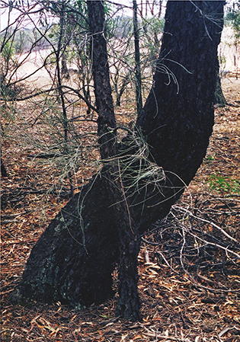

Strathlea
Photo by Frances Cincotta
April 2006

The 1852 Selwyn map shows much of our landscape as dotted with ‘sheoak’, or Buloke, now sadly depleted. Some patches remain, however, and there are encouraging signs of regrowth in parts of the region.

$75 framed $55 unframed

20. Acacia Horned Treehopper Sextius virescens on Golden Wattle Acacia pycnantha

Strangways
Photo by Patrick Kavanagh
December 2015

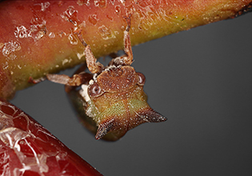

Seen side on, the tree hopper looks like a tiny cicada (less than 10 mm long), but the front view shows why it has its name. The insect is found on wattles in many parts of Australia; it’s slow moving, but a pretty good jumper when necessary. It’s often attended by ants, who protect it in return for feeding on a secretion produced by the Hopper.

$75 framed $55 unframed

21. Yellow Gum
Eucalyptus leucoxylon subsp. pruinosa

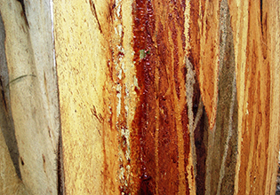

South German Track, Muckleford Forest
Photo by Janet Barker
April 2009

Summer – especially in a dry year – is a poor time for wildflowers, but some consolation can be found in the spectacular colour variations in Yellow Gum bark, which can sometimes resemble semi-abstract landscapes.

$75 framed $55 unframed

22. Immature Long-leaved Box Eucalyptus goniocalyx leaves

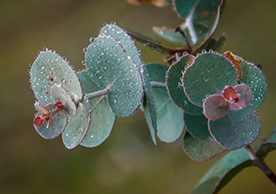

Fryerstown
Photo by Marion Williams
June 2015

A characteristic of some eucalypts is that a single tree can carry strikingly different shaped leaves. A single Long-leaved Box can have three distinct leaf shapes: juvenile or sucker leaves are rounded (and frankly quite cute, like the pictured samples); intermediate leaves can be long (up to 30 cm!); mature leaves longish (to 22 cm).

$75 framed $55 unframed

23. Long-leaved Box Eucalyptus goniocalyx juvenile leaf

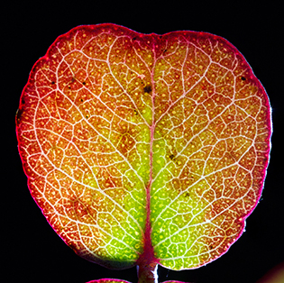

Strangways
Photo by Patrick Kavanagh
September 2014

The juvenile leaf of the Long-leaved Box is rounded, with a heart shaped dip – quite different from the adult leaves of the same species, which are long and spear shaped. The juvenile leaves don’t grow into adults: they’re the leaf found on a very young tree [or on a sucker branch on an older tree]. Healthy juveniles are grey green (see Marion William’s photo, Immature Long-leaved Box leaves): this macro shot highlights the veins and oil spots on a decaying leaf.

$95 framed $70 unframed

